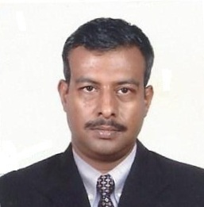
Dr. B S Deepak

Senior Level Consultant Surgeon
Targeting challenging assignments as Consultant with an organization of high repute preferably in overseas locations

deepaksatyapal@gmail.com +918699440709 / +917087182005

Profile Summary
- A highly qualified professional with nearly 14 years of rich expertise in General and Emergency Surgeries, Hospital Administration and Teaching.
- Proficient in resource allocation, budget planning and management of resources including equipment and machinery to ensure quality services being delivered to the patients.
- Proven skills in directing clinical and administrative operations, overseeing development and implementation of plans, operations, and programs within assigned service units.
- Areas of interest include: Teaching and Advanced Laparoscopic Surgery.
- Skilled in coaching the students by using interactive discussions to help students learn and get a better understanding of the concerned subject.
- Completed Basic Life Support Provider Course, accredited by American Heart Association (AHA) at Academy of Clinical Training TACT, Chennai.
- An effective communicator with excellent analytical, relationship management and problem solving skills.

Career Timeline  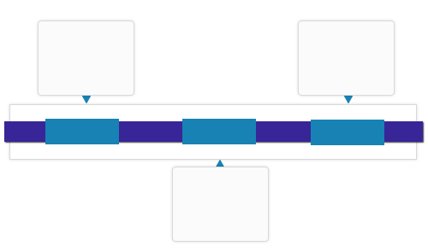  Since Dec’03  MS (General Surgery) from Pune University, Pune  Department of Surgery, Government  MBBS from Christian Medical College, CMC, Vellore, India  1992  2003  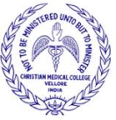  Education  - MRCS Eng (Royal College Of Surgeons)  - MS (General Surgery)-Pune University, Pune  - MBBS-Christian Medical College, CMC, Vellore, Tamil Nadu, India  Professional Affiliations  - Diplomate of National Board: DNB (Surgery) - Ministry of Family Welfare & Health, New Delhi MNAMS- Member of National Academy of Medical Sciences at Dip. of National Board, New Delhi.  - FAMIS-Fellowship in Advanced Minimally Invasive Surgery, Chennai  - Association of Surgeons of India, ASI.  - War Surgeon’s Chapter of Association of Surgeons of India. | Key Skills  Emergencies & Elective Operations  Hospital Administration  Consulting & Research  Laparoscopic Surgeries  Neurosurgeries  Gastrointestinal  Trauma Surgeries  Team Management  Soft Skills  Change Agent  Motivational Leader  Analytical/ Attention to Detail  Collaborator  Communicator  Planner
Work Experience
Since Dec’03: Department of Surgery, Government of India, Punjab
Joined as Medical Officer and after a series of promotion rose to the position of Consultant Surgeon
Deployment:
Oct’92-Oct’93 Francis Newton Hospital, Firozepur, Punjab ((Resident Surgery).
Nov’93-Nov’94 Christian Hospital, Jagadhri, Haryana as Medical Superintendent & Director
Nov’94-Nov’95 Philadelphia Mission Hospital, Ambala, Haryana (Resident Surgery)
Oct’95-Mar’01 Medical Officer-Government
Mar’01-Apr’03 Armed Force Medical College, Pune (MS General Surgery)
Mar’03-Present Senior Surgeon-Government.

Role:
- Performing screening assessment, treatment and referral of patients in accordance with Health Service policies; studying the medical case history.
- Interpreting the results of tests and examinations corroborate the line of treatment; advising on procedures for diagnosis / care attaching life-supporting equipment.
- Counseling the patients & their caregivers, discussing the patient's medical & developmental problems.
- Initiating and continuing, proper medical care of all patients assigned and to ensure proper documentation; managing critical care and work in cohesion with medical and paramedical team of Hospital setup.
- Formulating & implementing medical policies and presiding Medical Boards; developing protocols and procedures.
- Organizing & coordinating the hospital in a scientific manner to facilitate the performance of various medical faculties; monitoring prescribed standards of nursing care to the patients.
- Providing consultation and surgical assistance to other physicians and surgeons.

Highlights:
- Served in high altitude snowbound regions, remote border areas, operational and counter-insurgency scenarios, military hospitals and establishments across India.
- Supervised outpatient & Inpatient and ward care management.
- Worked on emergencies including trauma such as subclavian vein injury, GSW in a non-battlefield scenario, orthopedic emergencies, head injuries, burns and various GI surgical emergencies.
- Other Surgeries Hernias-adult and pediatric, Rectal surgeries, Breast surgery, Renal Calculus disease, Thyroid including Laparoscopic Surgery.
- Surgeries performed at highest altitudes: injuries due to extreme cold, High Altitude Cerebral Oedema & High Altitude Pulmonary Oedema.
- War injuries: Bullet Injuries, Liver lacerations, Splenic Rupture, Diaphragmatic/Chest injuries; injuries of the Small & Large gut.
Project: United Nations Peace Keeping Force Apr’07-May’08
Role:
- Led the establishment of a fully functional hospital in Ethiopia with the state-of-the-art equipment & facilities and insulated high quality material; mission provided health care to 300 local patients per day with free of cost medicines; received the Commendation by the United Nations Force Commander.
- Other responsibilities: procurement, indenting, quality control, packaging of equipment & dispatching of equipment from donor country.
- Worked in the capacity of Group Head and led a team of 14 doctors placed at far-flung places; managed a range of administrative work encompassing man management, procurement of equipment, distribution and maintenance of the same.

Teaching Experience

May’08-Mar’11: Military Hospital, Roorkee, Uttaranchal
Apr’14-till date: Military Hospital, Jalandhar, Punjab
Role:
- Taught group of students including Medical Students, Internists and Nursing Staff; provided consulting on variety of Surgical Emergencies including patient care and management in the wards.
- Supported the conduct of course for health workers and teachers in school, in collaboration with American Heart Association.
Publications

- Wrote publications featured in Indexed Journals.
International Surgery Journal: 2016, 3(3): 1638-1640.
05 publications are in the pipe line accepted.

Workshops

- Participated in multiple workshops on Advanced Laparoscopy.
- Basic Life Support Provider Course. Accredited by American Heart Association (AHA).

Personal Details

Date of Birth: 26th October 1967
Address: 16/4, Zorawar Enclave, Mall Road, Jalandhar Cantt, Jalandhar, Punjab.
Languages Known: English, Hindi, Tamil, Punjabi.
Availability 4-6 months
Family Details Spouse- House wife, Sons-2 (Elder son- Bachelor of Engineering 3rd yr at Thapar University, Patiala, Punjab, India: Younger son- Class 10th )
Extra Curricular Interests Event management, Painting, Music-Vocalist, Play the Guitar, Sports.

